Develop a basic Python Application

Please complete all the below tasks in Visual Studio Code and attach a screenshot once your code works and outputs to the console correctly.

**Student ID**: *102827175*

***Full Name***: *Duncan Macdonald*

# Tasks

1. Complete the “Python Hello World” page from [this online tutorial](https://www.quackit.com/python/tutorial/python_hello_world.cfm). Please attach a screenshot of both your code, and the output from the console below.

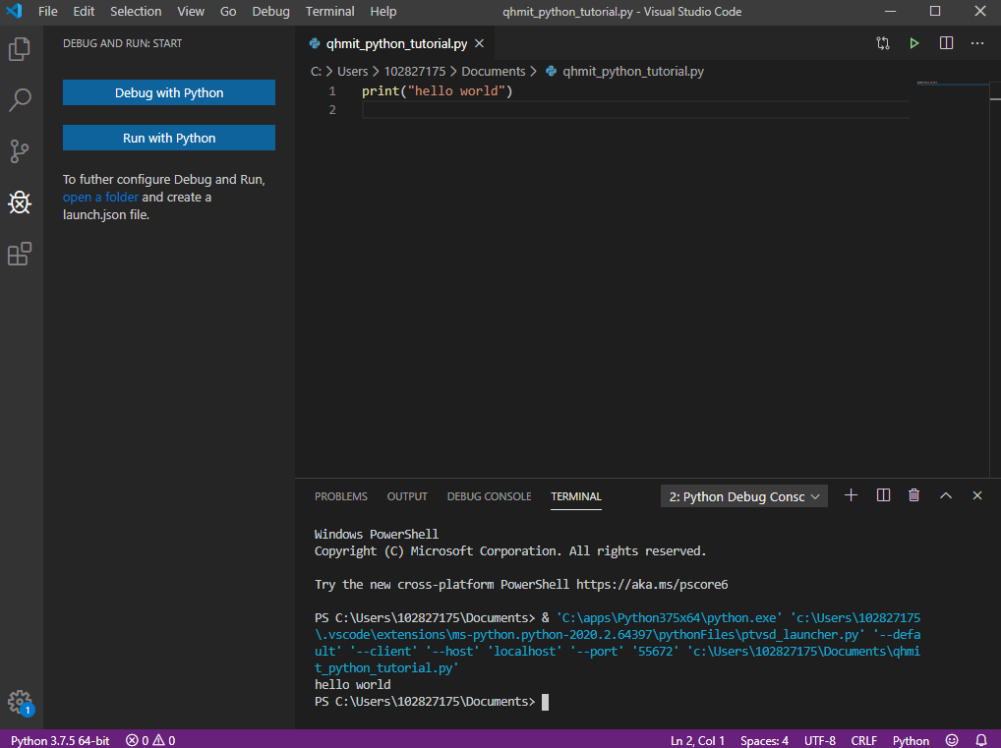

1. Complete the “Python Variables” page from [this online tutorial](https://www.quackit.com/python/tutorial/python_variables.cfm) up to “Case Sensitivity”. Please attach a screenshot of all your written code, and the output from the console below.

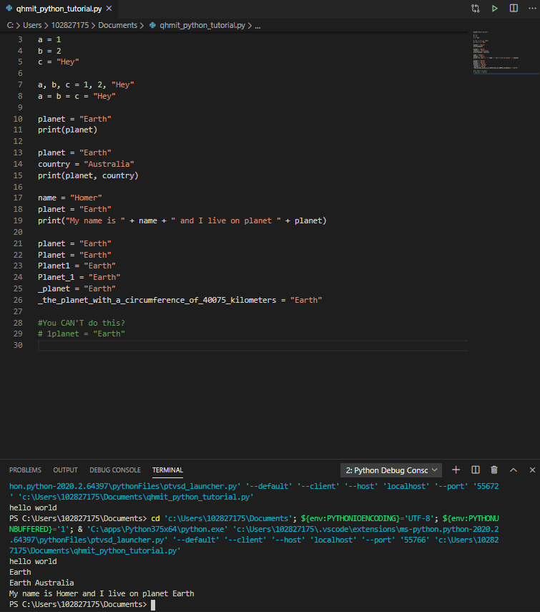

1. Complete the “Python User Input” page from [this online tutorial](https://www.quackit.com/python/tutorial/python_user_input.cfm).

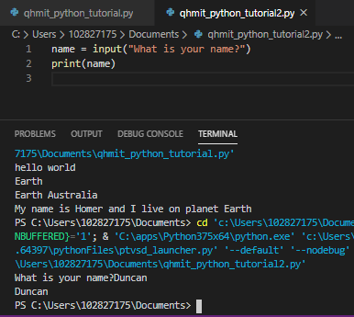

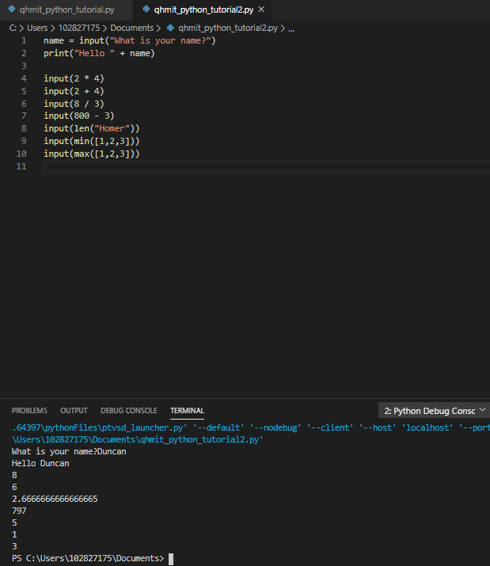

1. Create an application that can accept 3 words or sentences from the user and output a sentence using those words. I have provided some examples below. Please attach a screenshot of all your written code, and the output from the console below.
   1. Hey ‘Joe’! Stop ‘punching’ my ‘sandwich’.
   2. ‘Frank’ once ‘rode a waterslide’ and walked out with ‘no pants’

